Answer the following questions:

Be sure to provide **screenshots** along with your **explanations.**

1. Describe the purpose of each enhancement that you added to your app. Give brief descriptions of the enhancements and provide **screenshots** of important blocks and describe how you used them to solve certain programming problems. **Include these descriptions in your write-up, below.**

One of my enhancements was to add a score every time the player taps. If the score gets to ten the app will display you win tab. I also added a button to restart the game.

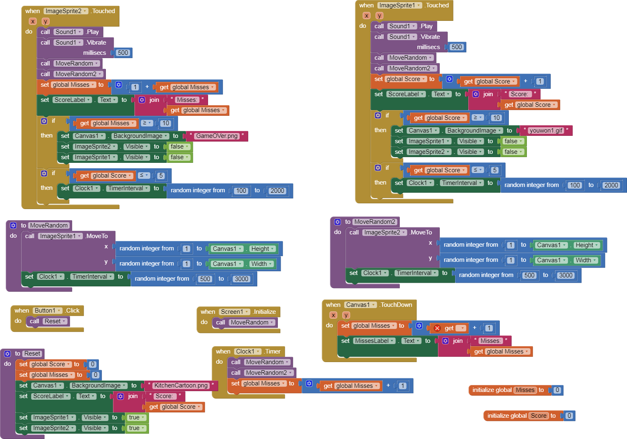

2. When the user touches an ImageSprite, both the Canvas.Touched and ImageSprite.Touched events are triggered. This is important for more complex games. For instance, suppose there are "good" and "bad" sprites in your game. If you hit one, you earn a point. If you hit the other, you lose two points. If you hit the Canvas and don't hit the ImageSprite, you lose 1 point. How would you code this?

**Answer**

|  |
| --- |
| **If the user taps the canvas you would remove 1 point. If you tap the second bad sprite it will subtract 2 points. If the user taps the good sprite it will give you 1 point. This is all completed using on tapped events.** |

3. How do you speed up the movement of the ImageSprite? What is the fastest it could move?

**Answer**

|  |
| --- |
| **You change the range of random numbers. It can move every 1 ms at the fastest.** |

# Score 9/10

# 2a.

|  |
| --- |
| My program is a game that moves health and unhealthy food around the screen. The user can tap these sprites and this will increase their score. When the user taps the unhealthy food it will lower their score that they get from tapping the healthy food. My video shows the function of when the user score gets to 10 it will hide the two foods and display a, you win, image. It also shows when your score gets to zero or less than zero it shows a, you lost, image. their, than |

# 2b.

|  |
| --- |
| My app started off with a template for the 4.2 apps. I made then advancements on the app. Some of these advancements were that two sprites were added to the screen one would subtract the score of the player and the other would add a score to the player. After this, I added a reset button that will reset the player's score.  Here your response should include details of the incremental (step by step) and iterative process you used to create your app. Obviously, you can’t say all the things you did, but you should have more detail than is written above. Also, the response here should include at least two difficulties or opportunities you encountered in the development process. You should identify the difficulty or opportunity and then describe how you resolved the difficulty or implemented the opportunity. At least two. |

# 2c.

|  |
| --- |
| I created this algorithm to add a score to the player every time they tap the sprite. It also moves the sprites randomly around the screen and vibrates and plays a sound everytime you tap the sprite. It then checks if the score is above 10 if it is it will display a “you win” screen. It also updates the text boxes every time so the score is displayed for the user. After doing all of this it checks if the misses is less then 0 if it is it will display a you lost screen. I don’t see the part that checks if misses less than 0. And finally it will check if the score is above 5. If it is then it will increase the difficulty by decreasing the time the sprites stay in the same spot. |

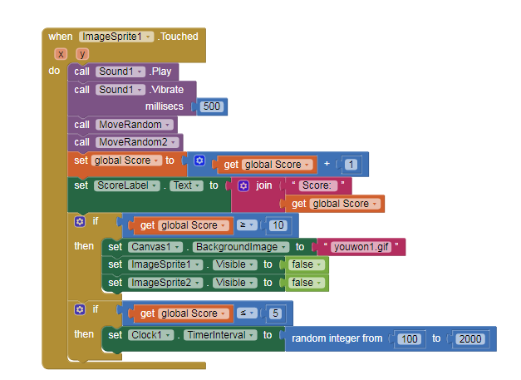

# 2d.

|  |
| --- |
| My app uses procedural abstractions to condense the code of randomly moving the sprites around. It does this by getting a random integer X from 1 to the height of the canvas. It repeats this for the Y also. It then does this every amount of seconds that is chosen from 500 to 3000. Clear this up. |



